Appendix D - Building an Agent with AgentSpace

# Overview

AgentSpace is a platform designed to facilitate an "agent-driven enterprise" by integrating artificial intelligence into daily workflows. At its core, it provides a unified search capability across an organization's entire digital footprint, including documents, emails, and databases. This system utilizes advanced AI models, like Google's Gemini, to comprehend and synthesize information from these varied sources.

The platform enables the creation and deployment of specialized AI "agents" that can perform complex tasks and automate processes. These agents are not merely chatbots; they can reason, plan, and execute multi-step actions autonomously. For instance, an agent could research a topic, compile a report with citations, and even generate an audio summary.

To achieve this, AgentSpace constructs an enterprise knowledge graph, mapping the relationships between people, documents, and data. This allows the AI to understand context and deliver more relevant and personalized results. The platform also includes a no-code interface called Agent Designer for creating custom agents without requiring deep technical expertise.

Furthermore, AgentSpace supports a multi-agent system where different AI agents can communicate and collaborate through an open protocol known as the Agent2Agent (A2A) Protocol. This interoperability allows for more complex and orchestrated workflows. Security is a foundational component, with features like role-based access controls and data encryption to protect sensitive enterprise information. Ultimately, AgentSpace aims to enhance productivity and decision-making by embedding intelligent, autonomous systems directly into an organization's operational fabric.

# How to build an Agent with AgentSpace UI

Figure 1 illustrates how to access AgentSpace by selecting AI Applications from the Google Cloud Console.

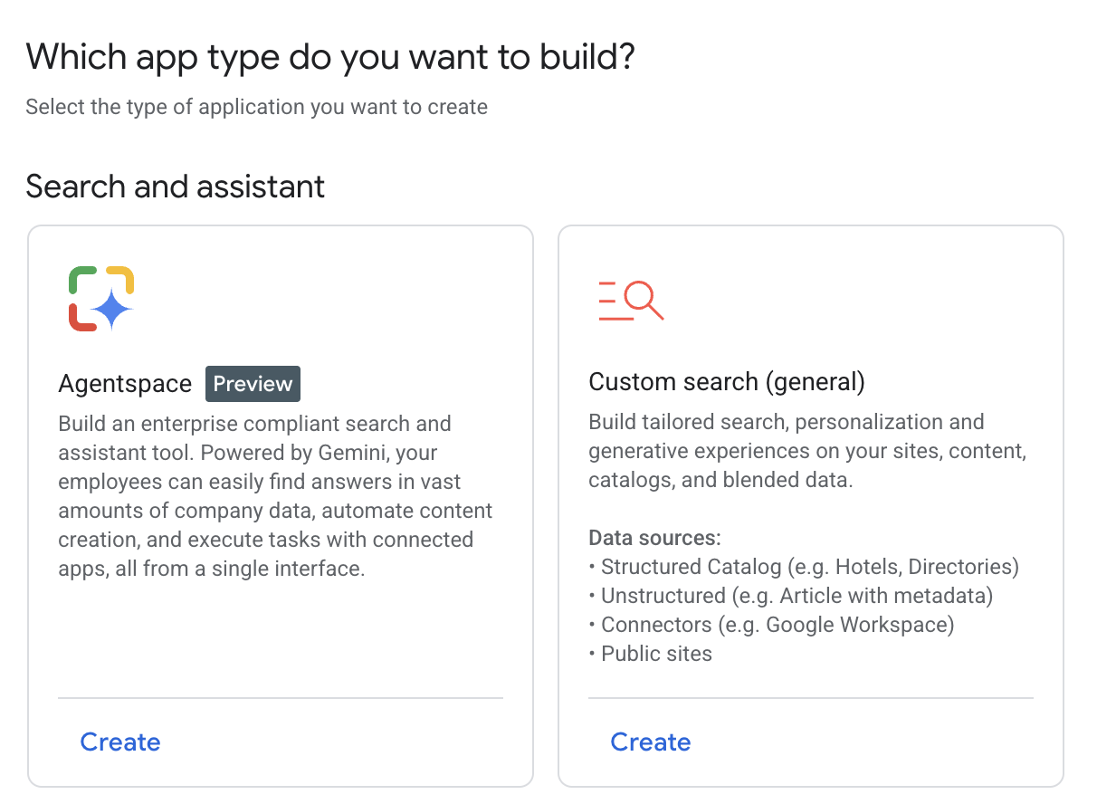

Fig. 1: How to use Google Cloud Console to access AgentSpace

Your agent can be connected to various services, including Calendar, Google Mail, Workaday, Jira, Outlook, and Service Now (see Fig. 2).

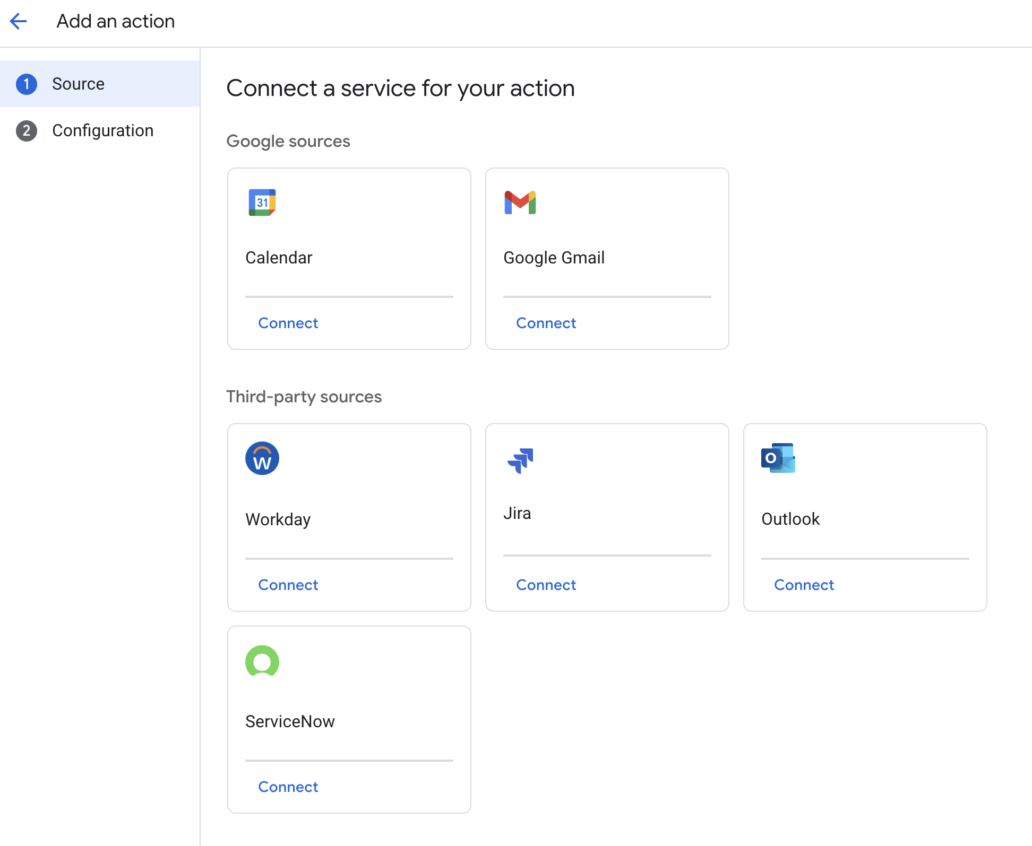

Fig. 2: Integrate with diverse services, including Google and third-party platforms.

The Agent can then utilize its own prompt, chosen from a gallery of pre-made prompts provided by Google, as illustrated in Fig. 3.

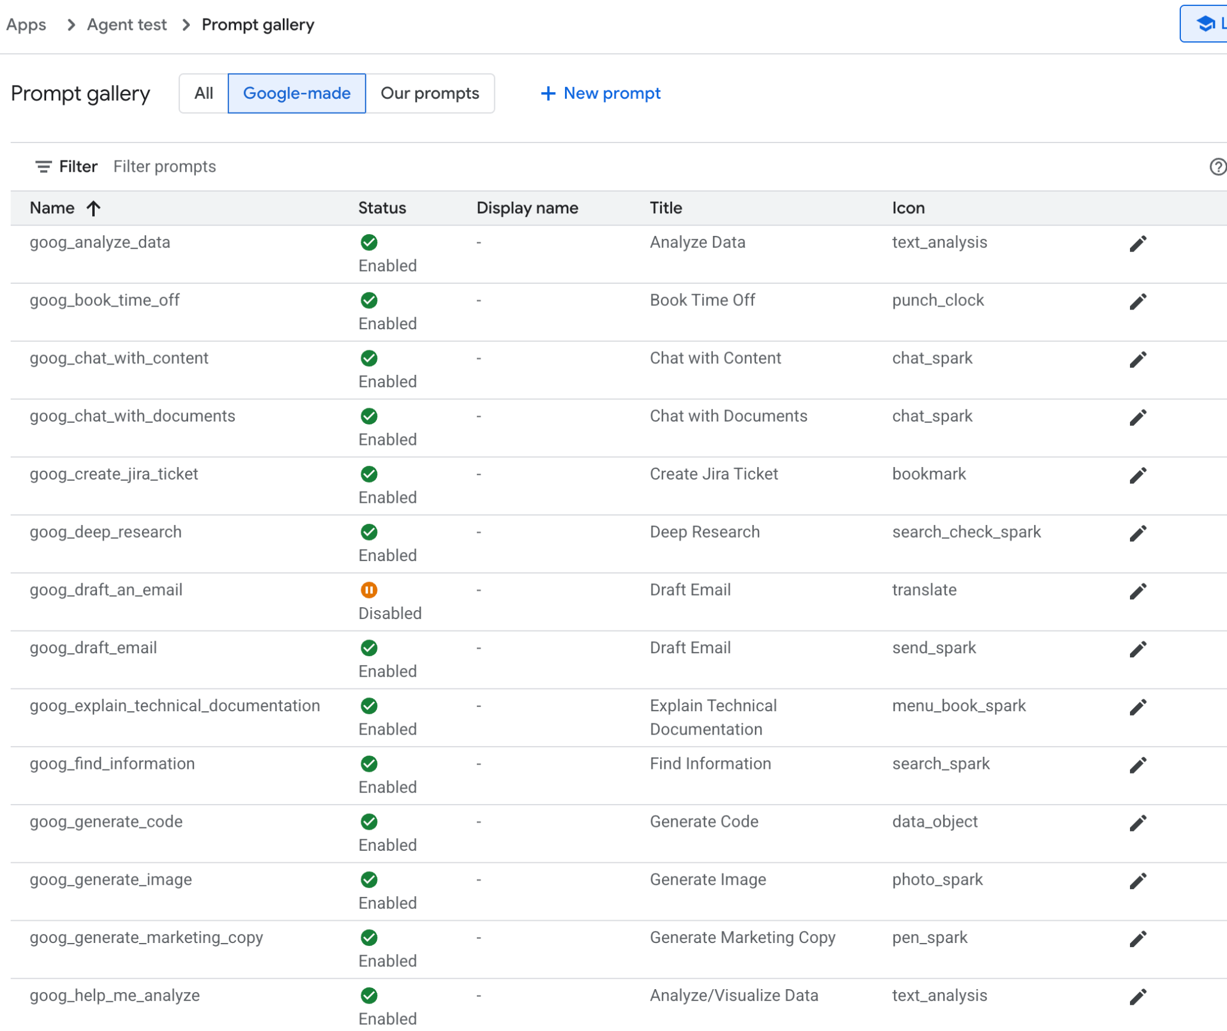

Fig.3: Google's Gallery of Pre-assembled prompts

In alternative you can create your own prompt as in Fig.4, which will be then used by your agent

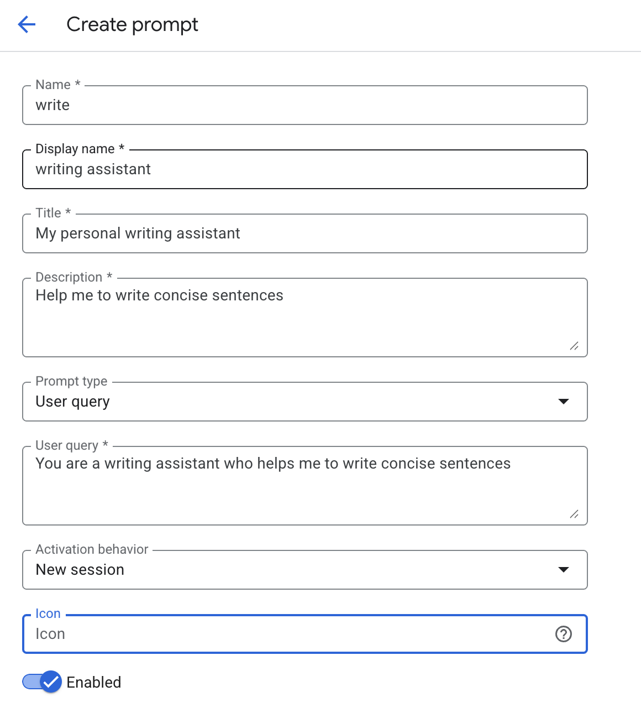

Fig.4: Customizing the Agent's Prompt

AgentSpace offers a number of advanced features such as integration with datastores to store your own data, integration with Google Knowledge Graph or with your private Knowledge Graph, Web interface for exposing your agent to the Web, and Analytics to monitor usage, and more (see Fig. 5)

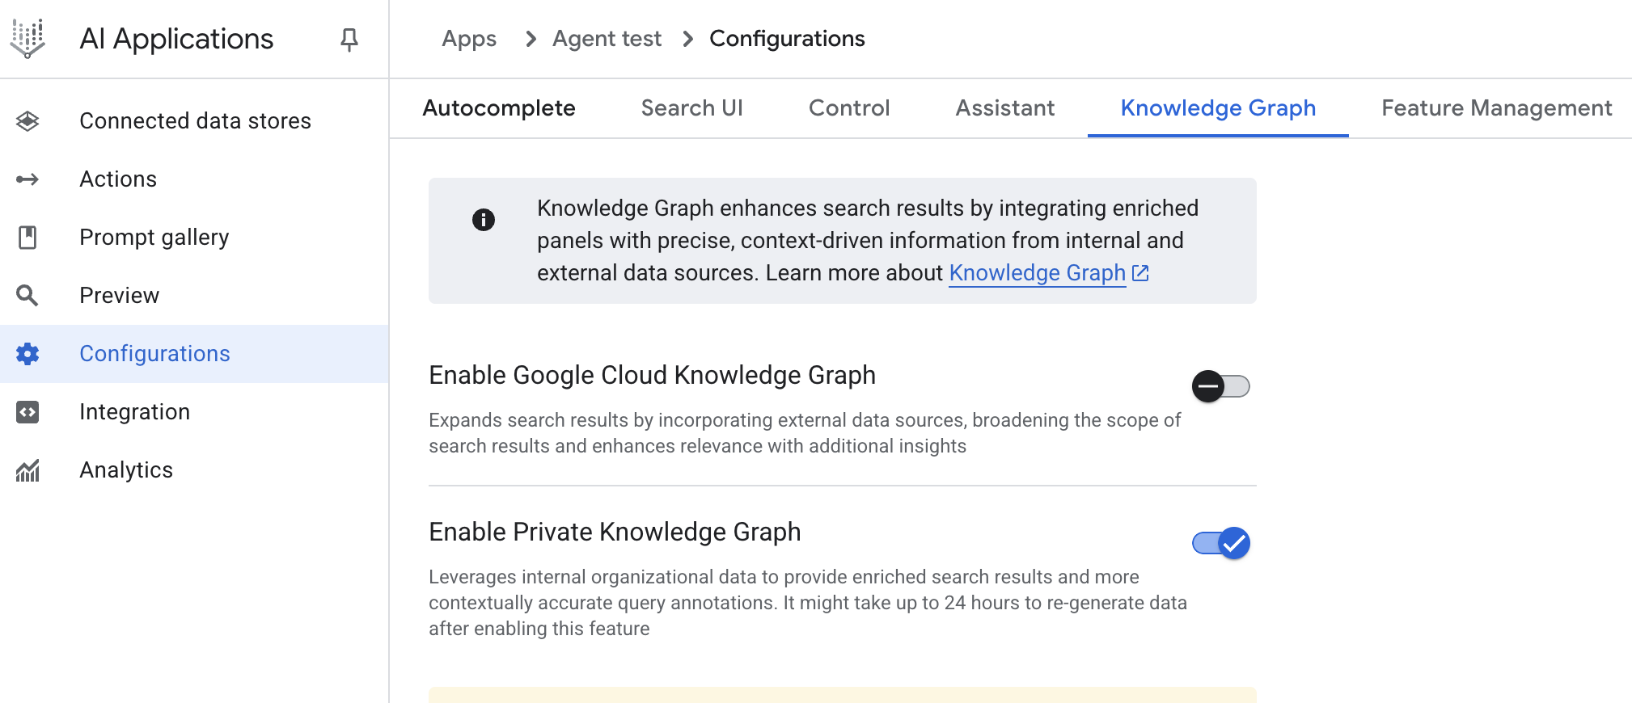

Fig. 5: AgentSpace advanced capabilities

Upon completion, the AgentSpace chat interface (Fig. 6) will be accessible.

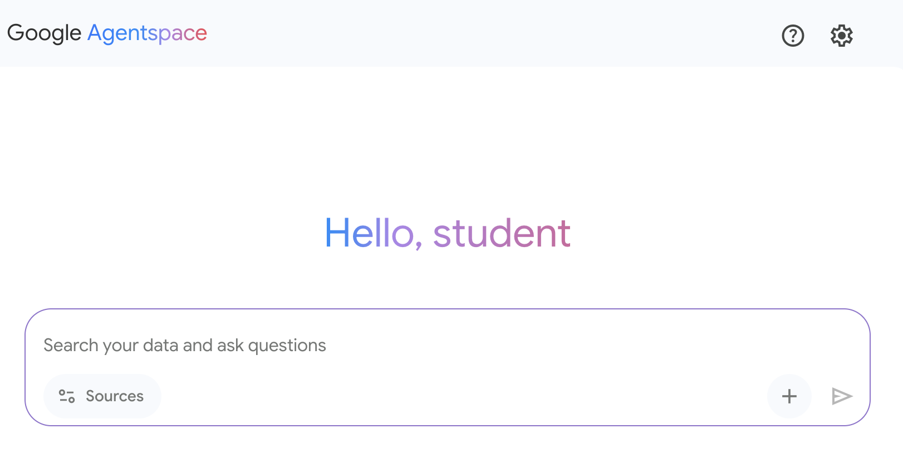

Fig. 6: The AgentSpace User Interface for initiating a chat with your Agent.

# Conclusion

In conclusion, AgentSpace provides a functional framework for developing and deploying AI agents within an organization's existing digital infrastructure. The system's architecture links complex backend processes, such as autonomous reasoning and enterprise knowledge graph mapping, to a graphical user interface for agent construction. Through this interface, users can configure agents by integrating various data services and defining their operational parameters via prompts, resulting in customized, context-aware automated systems.

This approach abstracts the underlying technical complexity, enabling the construction of specialized multi-agent systems without requiring deep programming expertise. The primary objective is to embed automated analytical and operational capabilities directly into workflows, thereby increasing process efficiency and enhancing data-driven analysis. For practical instruction, hands-on learning modules are available, such as the "Build a Gen AI Agent with Agentspace" lab on Google Cloud Skills Boost, which provides a structured environment for skill acquisition.

# References

1. Create a no-code agent with Agent Designer, <https://cloud.google.com/agentspace/agentspace-enterprise/docs/agent-designer>
2. Google Cloud Skills Boost, <https://www.cloudskillsboost.google/>

***[Extracted Text from image2.png]***

*OCR Method: --psm 3*

Which app type do you want to build?  
  
Select the type of application you want to create  
  
Search and assistant  
  
Ut  
  
Agentspace  
  
Build an enterprise compliant search and  
assistant tool. Powered by Gemini, your  
employees can easily find answers in vast  
amounts of company data, automate content  
creation, and execute tasks with connected  
apps, all from a single interface.  
  
Create  
  
=Q  
  
Custom search (general)  
  
Build tailored search, personalization and  
generative experiences on your sites, content,  
catalogs, and blended data.  
  
Data sources:  
  
+ Structured Catalog (e.g. Hotels, Directories)  
+ Unstructured (e.g. Article with metadata)  
  
+ Connectors (e.g. Google Workspace)  
  
+ Public sites  
  
Create

--------------------------------------------------

***[Extracted Text from image3.png]***

*OCR Method: --psm 3*

Al Applications A Apps > Agenttest > Configurations  
  
vy  
@ Connected data stores Autocomplete Search UI Control Assistant Knowledge Graph Feature Management  
= Actions  
Knowledge Graph enhances search results by integrating enriched  
9) Pp y integ 9  
  
a Prompt gallery panels with precise, context-driven information from internal and  
Q external data sources. Learn more about Knowledge Graph 4%  
  
Preview  
% = Configurations  
  
Enable Google Cloud Knowledge Graph @>  
  
Integration Expands search results by incorporating external data sources, broadening the scope of  
  
search results and enhances relevance with additional insights  
Analytics  
  
Enable Private Knowledge Graph av)  
  
Leverages internal organizational data to provide enriched search results and more  
contextually accurate query annotations. It might take up to 24 hours to re-generate data  
after enabling this feature

--------------------------------------------------

***[Extracted Text from image1.png]***

*OCR Method: --psm 4*

Apps > Agenttest > Prompt gallery al  
  
Prompt gallery All | Google-made | Our prompts + New prompt  
  
= Filter Filter prompts @  
  
Name 4 Status Display name Title Icon  
  
goog_analyze_data g - Analyze Data text_analysis c  
Enabled  
  
goog_book_time_off [Vv] - Book Time Off punch_clock c  
Enabled  
  
goog_chat_with_content g . Chat with Content chat_spark t  
Enabled  
  
goog_chat_with_documents [V) - Chat with Documents chat_spark at  
Enabled  
  
goog_create_jira_ticket g - Create Jira Ticket bookmark ct  
Enabled  
  
goog_deep_research Gg - Deep Research search_check_spark c  
Enabled  
  
goog_draft_an_email oO - Draft Email translate a  
Disabled  
  
goog_draft_email g - Draft Email send_spark a  
Enabled  
  
goog_explain_technical_documentation g - Explain Technical menu_book_spark t  
Enabled Documentation  
  
goog_find_information g - Find Information search_spark c  
Enabled  
  
goog_generate_code Gg - Generate Code data_object &  
Enabled  
  
goog_generate_image [V) - Generate Image photo_spark 7  
Enabled  
  
goog_generate_marketing_copy g - Generate Marketing Copy pen_spark t  
Enabled  
  
goog_help_me_analyze g - Analyze/Visualize Data text_analysis c  
  
Enabled

--------------------------------------------------

***[Extracted Text from image5.png]***

*OCR Method: --psm 4*

<€ Create prompt  
  
- Name *  
write  
  
- Display name *  
writing assistant  
  
- Title *  
My personal writing assistant  
  
- Description *  
Help me to write concise sentences  
  
4  
  
-- Prompt type  
User query v  
  
- User query *  
You are a writing assistant who helps me to write concise sentences  
  
4  
  
- Activation behavior  
New session v  
  
Icon  
Icon (O)  
  
ay) Enabled

--------------------------------------------------

***[Extracted Text from image4.png]***

*OCR Method: --psm 4*

Google Agentspace  
  
Hello, student  
  
QO 8  
  
Search your data and ask questions  
  
25 Sources  
  
+ &

--------------------------------------------------

***[Extracted Text from image6.png]***

*OCR Method: --psm 4*

€ = Addanaction  
  
@ Source Connect a service for your action  
  
Configuration  
2 g Google sources  
  
a M:  
  
Calendar Google Gmail  
  
Connect Connect  
  
Third-party sources  
  
® a fo  
  
Workday Jira Outlook  
Connect Connect Connect  
ServiceNow  
  
Connect

--------------------------------------------------